**More on the CLI & Angular projects**

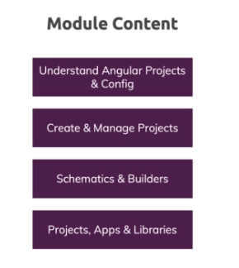

**A Closer Look at "ng new"**

https://paper-attachments.dropbox.com/s_58E0B38B34D6C4679B7E37D9C13951B2AF037C180BD6D2D8320C312E4E4C0E4F_1638003730940_screenshot-www.udemy.com-2021-11-27-14-32-03-961.png

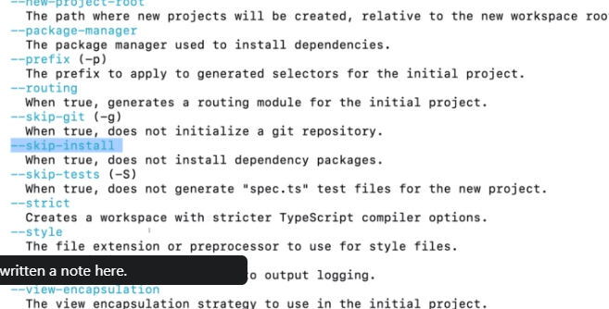

**IDE & Project Setup**

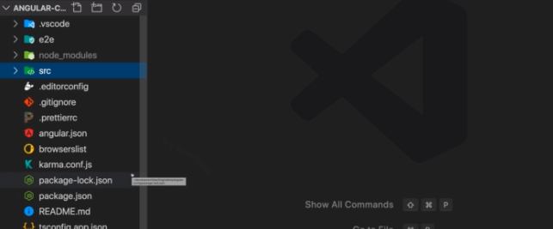

**Understanding the Config Files**

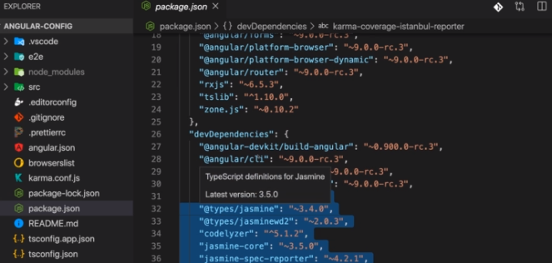

**Important CLI Commands**

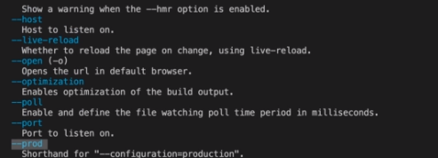

**The "angular.json" File - A Closer Look**

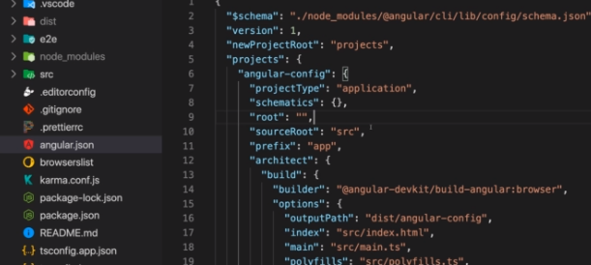

**Angular Schematics - An Introduction**

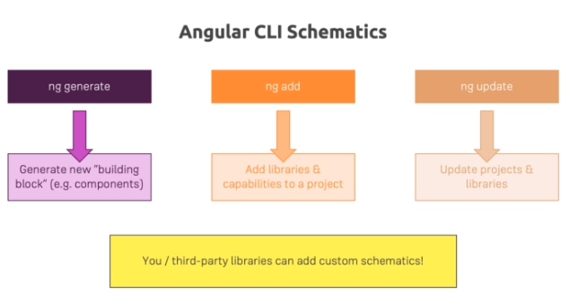

**The "ng add" Command**

https://paper-attachments.dropbox.com/s_58E0B38B34D6C4679B7E37D9C13951B2AF037C180BD6D2D8320C312E4E4C0E4F_1638004158328_screenshot-www.udemy.com-2021-11-27-14-39-12-490.png

**Using Custom "ng generate" Schematics**

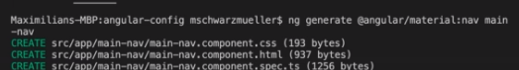

**Smooth Updating of Projects with "ng update"**

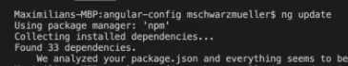

**Simplified Deployment with "ng deploy"**

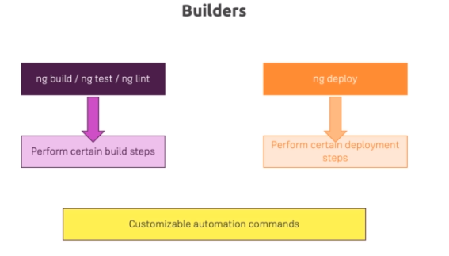

**Understanding "Differential Loading”**

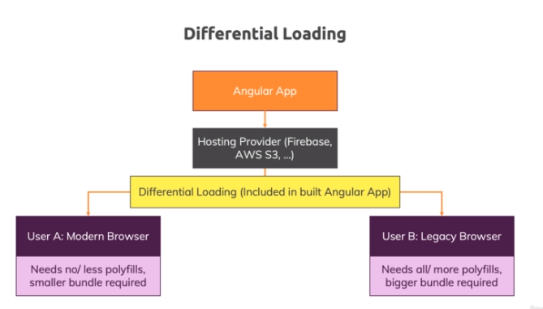

**Angular Libraries - An Introduction**

